Assignment 6.05: Springs and Elastic Potential Energy

- Lance has a spring with a spring constant of 500 N/m. He hangs the spring from the ceiling and pulls down on it, stretching it 0.3 meters.
  - What is the force that the spring exerts on his hand?

  - Is the force up or down?

  - What is the energy stored in the spring?

- Ashley drives her car over a speed bump, causing a spring in her car's shock-absorbing system to be compressed a distance of 0.2 meters. The force exerted on the spring is 3500 N.
  - What is the spring constant for this spring?

  - What is the energy that is stored in this spring?

- Shin-Hae attaches a spring to a wall, and pulls on the spring with a force of 225 N. The spring has a spring constant of 1000 N/m.
  - What is the distance the spring stretches?

  - What is the energy stored in the spring?

- Eunice stretches a rubber band a distance of 0.2 m. The rubber band stores a potential energy of 1.2 J.
  - What is the spring constant of the rubber band?

  - What is the force that the rubber band is exerting on her hand?

- A spring-based jumping toy has a mass of 1 gram, as shown in the picture. It is compressed a distance of 2 cm, where a suction cup momentarily holds it in place. When the suction cup releases, the toy “jumps” to a height of 0.56 meters.

  - What is the gravitational potential energy the toy has at the top of its path?

  - What is the elastic potential energy that was stored in the spring before the toy “jumped”?

  - What is the spring constant?

- Lucas has a mass of 45 kg. He lies down on his bed to take a nap, compressing 15 springs in his bed equally. If his weight is distributed equally on each spring, and all the springs in his bed have a spring constant of 1015 N/m, how far is each spring compressed?

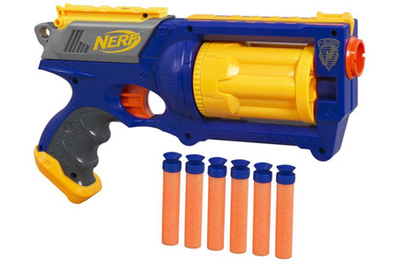
- Christopher uses a Nerf® gun to shoot Manuel. He pulls back on the “hammer”, causing a spring to compress a distance of 0.1 meters. The mass of a Nerf® dart is 0.002 kg. The final velocity of the dart is 4.3 m/s. Use the law of conservation of energy to calculate the spring constant of the spring inside the Nerf® gun.

